# 

**7.1: Activation Functions** **1**

7.1.1: Setting the context 1

7.1.2: Saturation in logistic neuron 2

7.1.3: Zero centered functions 4

7.1.4: Introducing Tanh and ReLU activation functions 6

7.1.5: Tanh and ReLU Activation Functions 8

**7.2: Initialization Methods** **10**

7.2.1: Symmetry Breaking Problem 10

7.2.2: Xavier and He Initialization 11

7.2.3: Summary and what next 13

# 

# 7.1: Activation Functions

## 7.1.1: Setting the context

The progress of DL over the past decade

1. In this section, we will be looking at how better activation functions and better weight initialization has sped up the growth of DL over the last decade
2. Why are activation functions important?
   1. Consider a network where there are no non-linear activation functions like sigmoid etc.
   2. Here
   3. It can only represent linear relations between x and y
   4. Universal Approximation Theorem does not hold good.
   5. The **representation power** of a deep NN is due to its **non-linear activation functions**
3. Some popular non-linear activation functions are
   1. Logistic - can be called a sigmoid function
   2. tanh - can be called a sigmoid function
   3. ReLU
   4. Leaky ReLU

## 7.1.2: Saturation in logistic neuron

Let’s look at the logistic function

1. The following figure illustrates the logistic function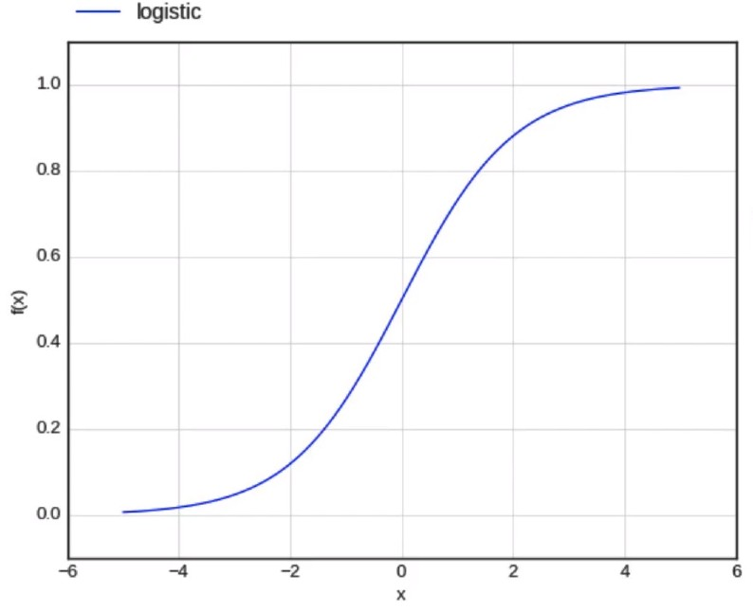
$f(x) = \frac{1}{1 + e^{-x}}$

$f'(x) = \frac{∂f(x)}{∂x} = f(x) * (1 - f(x))$

2. A logistic neuron is said to be saturated when it reaches its peak values when it is given high extremes of positive or negative values as inputs.
   1. When $f(x) =0$
   2. And hence $f'(x) =0$
   3. In the case where we are calculating the gradient w.r.t a weight associated with a saturated neuron, the saturated neuron’s derivative is 0, thus resulting in the entire gradient becoming 0
   4. This is because the term associated with the saturated neuron in the chain rule for gradient calculation becomes 0, thus making the entire gradient 0
   5. Due to this, the weights are not updated.
   6. This is called the **Vanishing Gradient Problem**, because the gradient vanishes or becomes 0 due to the presence of a saturated neuron.

## 7.1.3: Zero centered functions

1. Why do logistic neurons saturate?
   1. Consider a pre activation function: $a = {Σ^{n}}_{i=1}w_{n}x_{n}$
   2. And the activation function 
   3. In cases where the weights are initialised to very high or very low values, the weighted summation term (a) will become very large or very small (very negative).
   4. This could result in the neuron attaining saturation
   5. Remember to initialise the weights to small values
2. Another shortcoming with the logistic function is that it is not zero centered
   1. Zero centered: The function is spread out equidistant around the 0 point, i.e. it takes an equal number of positive and negative values.
   2. The logistic function ranges from 0 to 1
   3. The tanh function is a zero centered sigmoid function
3. Consider the simple neural network with logistic sigmoid neurons
   1. Consider the following gradients
 $∇w_{1} = (\frac{∂L(w)}{∂y}\frac{∂y}{∂h_{3}}\frac{∂h_{3}}{∂a_{3}}) * \frac{∂a_{3}}{∂w_{1}} =(\frac{∂L(w)}{∂y}\frac{∂y}{∂h_{3}}\frac{∂h_{3}}{∂a_{3}}) * h_{21}$

 $∇w_{2} = (\frac{∂L(w)}{∂y}\frac{∂y}{∂h_{3}}\frac{∂h_{3}}{∂a_{3}}) * \frac{∂a_{3}}{∂w_{2}} =(\frac{∂L(w)}{∂y}\frac{∂y}{∂h_{3}}\frac{∂h_{3}}{∂a_{3}}) * h_{22}$

 2. The bracketed terms are common
   3. Both h21 and h22 are outputs of the logistic function, so they are always positive (i.e. ranging from 0 to 1)
   4. Due to this, at all times, both $∇w_{1}$ and $∇w_{2}$ will always be of the same sign, either positive or negative. They cannot be different from each other since the bracketed part is common between them and the logistic function output is always positive
   5. The gradients w.r.t all the weights connected to the same neuron are either all +ve or all -ve
   6. Thus, this limits the directions in which the weights can be updated
4. Thus, we cannot arrive at the local minima as fast as possible by moving in all directions.
5. Also, logistic function is computationally expensive because of ex

## 7.1.4: Introducing Tanh and ReLU activation functions

What are the other alternatives to the Logistic function?

1. **tanh**
   1. The following figure illustrates the tanh function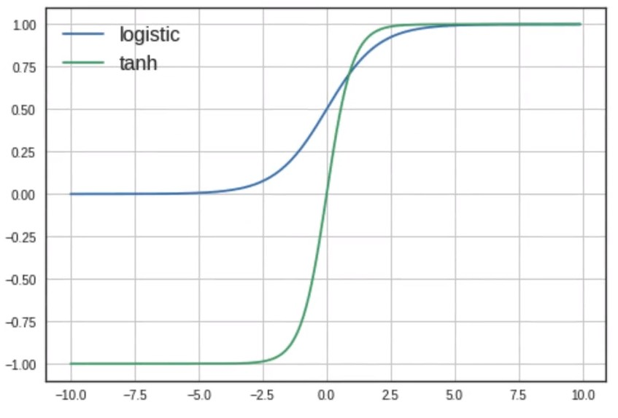
 $f(x) = \frac{e^{x}-e^{-x}}{e^{x} + e^{-x}}$

 $f'(x) = \frac{∂f(x)}{∂x} = (1 - (f(x{))}^{2})$

 2. The tanh function ranges from -1 to +1, whereas the logistic function ranges from 0 to 1
   3. It is a zere centered function.
   4. The function saturates at f(x) = -1 or 1, thus causing the gradients to vanish.
   5. tanh is computationally expensive because of ex
   6. However, it is still preferred over the logistic function
2. **ReLU**
   1. The following figure illustrates the ReLU function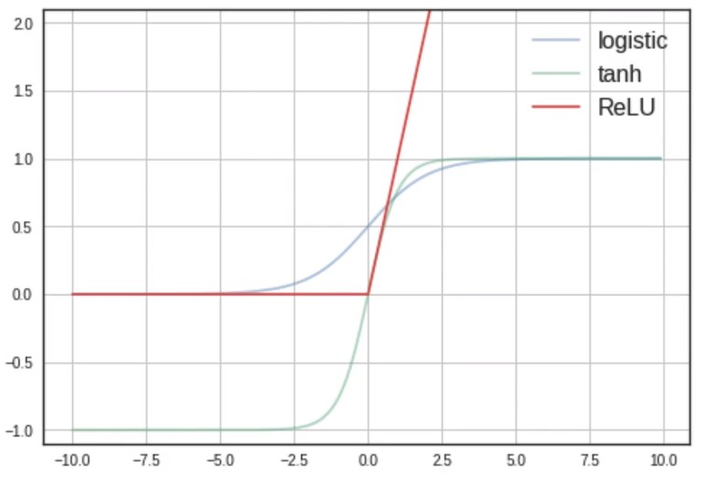
 $f(x) = max(0, x)$

 $f'(x) = \frac{∂f(x)}{∂x} =0 if x<0 | 1 if x>0$

 2. ReLU outputs the input value itself if it is positive, else it outputs zero, i.e. f(1) = 1, f(-1) = 0
   3. It does not saturate in the positive region
   4. It is not zero centered
   5. Easy to compute (no expensive ex)

## 7.1.5: Tanh and ReLU Activation Functions

Is there any caveat in using ReLU?

1. Consider the following deep neural network that uses the ReLU activation function 
   1. What happens if b takes on a large negative value due to a large negative update $∇b$ at some point?
   2. $w_{1}x_{1} + w_{2}x_{2} + b < 0$ [if b << 0]
   3. Therefore $h_{1}= 0$ [dead neuron]
   4. Which means $\frac{∂h_{1}}{∂a_{1}}= 0$
   5. This zero derivative is involved in the chain rule for computing the gradient w.r.t ${∇w_{1}}_{}$
   6. ${∇w_{1} becomes 0}_{}$ leading to the weight not being updated, as in the case of a **saturated neuron**.
   7. This also applies to ${∇w_{2}}_{}$ and ${∇b}_{}$, their parameters are not updated.
   8. Here, x1 and x2 have been normalised, so they range between 0-1 and are therefore unable to counterbalance any large negative value b
   9. This means that once a neuron has died, it remains dead forever, as no new input would be large enough to counter the negative b value
   10. Thus, there is a very real problem of saturation of a ReLU neuron in the negative region.
   11. In practice, if there is a large number of ReLU neurons, a large fraction (up to 50%) may die during operation if the learning rate is set too high
   12. It is advised to initialise the bias to a positive value
   13. Using other variants of ReLU is recommended
2. A good alternative is the **Leaky ReLU**
   1. The following figure illustrates the leaky ReLU function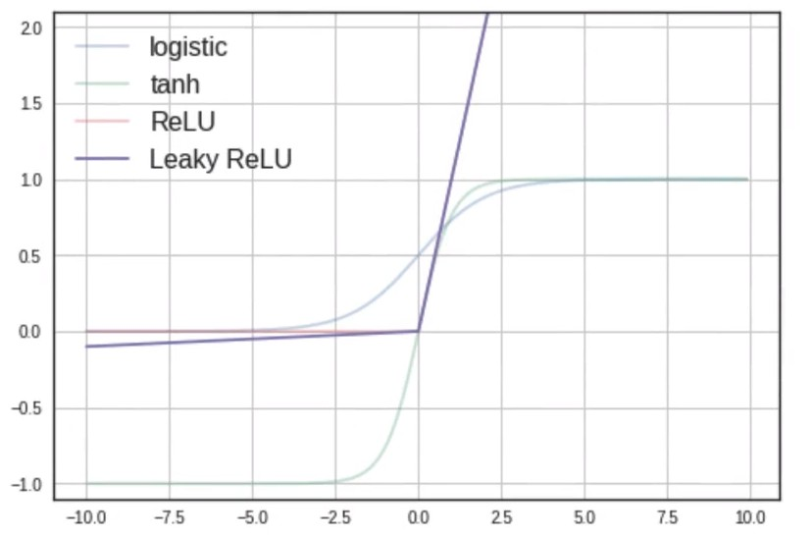
 $f(x) = max(0.01x, x)$

 $f'(x) = \frac{∂f(x)}{∂x} =0.01 if x<0 | 1 if x>0$

 2. ReLU outputs the input value itself if it is positive, else it outputs a fraction of the input value, i.e. f(2) = 2, f(-2) = 0.02
   3. It does not saturate in the positive or negative region
   4. Will not die (0.01x ensures that at least a small gradient will flow through), this means that there isn’t any 0 valued derivative, thereby ensuring that the gradients are all non-zero. Thus, the weights are always updated.
   5. It is easy to compute (no expensive ex)
   6. Close to zero centered outputs

# 7.2: Initialization Methods

## 7.2.1: Symmetry Breaking Problem

Why not simply initialise all weights to 0?

1. Consider the following neural network that uses the logistic activation function
   1. Let us initialise all the weights to 0
 $a_{11}=a_{12}=0$

 $h_{11}=h_{12}$

 $∇w_{11}= \frac{∂L(w)}{∂y}.\frac{∂y}{∂h_{11}}.\frac{∂h_{11}}{∂a_{11}}.x_{1}$

$∇w_{21}= \frac{∂L(w)}{∂y}.\frac{∂y}{∂h_{12}}.\frac{∂h_{12}}{∂a_{12}}.x_{2}$

2. But $h_{11}=h_{12}$ and $a_{11}=a_{12}$
   3. Therefore $∇w_{11} = ∇w_{21}$
   4. We can see that if we initialise the weights to equal values, then the equality carries through to the gradients associated with these weights, thereby keeping the weights equal throughout the training.
   5. This is known as the Symmetry Breaking Problem, where if you start with equal initialised weights, they remain equal through the training.
   6. Hence weights connected to the same neuron should never be initialised to the same value?
2. Some conclusions we can make are as follows
   1. Never initialise all weights to 0
   2. Never initialise all weights to the same value

## 7.2.2: Xavier and He Initialization

Why shouldn’t you initialise all the weights to large values?

1. Consider the following neural network that uses the logistic activation function
   1. Here, input values are normalised (0-1) and the weights are initialised to large values
   2. This would result in the function attaining saturation.
   3. Thus, a few noteworthy points are:
      1. Always normalise the inputs (should lie between 0 to 1). If not, they too could contribute to saturation if their values are very large or small
      2. Never initialise weights to large values
   4. To reinforce the points we made earlier about initialisation
      1. Never initialise all weights to 0
      2. Never initialise all weights to the same value
      3. Never initialise all weights to large values
2. Let’s look at a sample neural network and consider some alternate initialisation methods
3. **Xavier initialisation**:
   1. Consider $a_{21}= w_{21}h_{11} + w_{22}h_{12} + ... + w_{2m}h_{1m}$
   2. Here, as the number of input neurons increase (m>>0), the value of a21 could potentially be very high. Thus to avoid saturation due to a extremely large value, it is recommended that the weights scale inversely with the number of input neurons, i.e. $w ∝ \frac{1}{m}$
   3. The python implementation is as follows 
   4. Here, np.rand.randn gives a value between 0-1 from the normal distribution. This m x n matrix is then divided by the sq.root of m. This prevents a21 from blowing up to a very large value. Used in the case of **tanh and logistic activations**
4. **He Initialisation**:
   1. It is used for ReLU and Leaky ReLU
   2. Here is the python implementation
   3. Here, we divide by $\sqrt{m/2}$ because of the rough intuition that in ReLU, around half the neurons die during training.

## 7.2.3: Summary and what next

What have we learned in this chapter?

1. **Activation Functions**
   1. Logistic (❌ Not used much in practice)
   2. tanh (RNNs)
   3. ReLU (CNNs)
   4. Leaky ReLU (CNNs)
2. **Initialisation Methods**
   1. Zero, Equal, Large (❌ Not used)
   2. Xavier initialisation (tanh, logistic)
   3. He initialisation (ReLU)
3. Activation functions and initialisation methods go hand-in-hand, and together, they try to avoid the problem of vanishing gradients and saturation